DEPARTMENT OF ARTIFICIAL INTELLIGENCE AND DATA SCIENCE

MINI PROJECT REPORT
EMPLOYEE ATTRITION ANALYSIS AND PREDICTION
Data Preparation, Exploratory Analysis, Machine Learning Model Development, Evaluation and Comparison

Submitted by
SRI SREYA M
THRISHA S
II AI & DS – C

Under the Guidance of
V. EZHIL SWANLY

SRM TRP Engineering College
Tiruchirappalli
Submission Date: 24/10/2026

TABLE OF CONTENTS
- ABSTRACT
- CHAPTER 1 – PROBLEM DEFINITION
- CHAPTER 2 – DATASET DESCRIPTION
- CHAPTER 3 – METHODOLOGY AND DATA PREPARATION
- CHAPTER 4 – EXPLORATORY DATA ANALYSIS
- CHAPTER 5 – MODEL DEVELOPMENT
- CHAPTER 6 – MODEL EVALUATION
- CHAPTER 7 – MODEL COMPARISON
- CHAPTER 8 – RESULT ANALYSIS
- CONCLUSION
- REFERENCES
- APPENDIX – DELIVERABLES CHECKLIST

ABSTRACT
Employee attrition refers to employees leaving an organization during a particular period. Understanding attrition patterns can help an organization examine workforce stability and consider appropriate employee-retention strategies.
This project proposes an end-to-end workflow for Employee Attrition Analysis and Prediction using Python. It includes dataset inspection, data cleaning, exploratory data analysis (EDA), visualization, supervised classification, model evaluation, and comparison. The target variable is Attrition, where the dataset’s documented labels (commonly Yes/No) indicate whether an employee left.
Three candidate classifiers are included: Logistic Regression, Decision Tree, and Random Forest. Performance will be assessed using accuracy, precision, recall, F1-score, confusion matrix, and—where appropriate—ROC-AUC. Since the actual dataset and completed model outputs are not available in this report-generation step, numerical results are intentionally left as placeholders and must be filled from the executed notebook. The project is educational and should not be used to make automated decisions about individual employees.

CHAPTER 1 – PROBLEM DEFINITION
- 1.1 Problem Statement
Organizations may find it difficult to understand employee turnover when employee information is stored in raw tables with missing values, duplicates, inconsistent categories, and many different attributes. This project analyzes employee data to identify descriptive patterns associated with attrition and develops baseline machine-learning classifiers to estimate the Attrition label when suitable labelled data is available.
- 1.2 Prediction Problem
This is a supervised binary-classification problem if the Attrition column contains two documented classes, such as Yes and No. The model learns patterns from labelled employee records and predicts the class for held-out records. Predictions indicate associations in the dataset; they do not establish why a person leaves.
- 1.3 Target Variable
Target variable: Attrition. Use the exact class labels and meaning documented by the selected dataset. If the dataset does not contain a reliable Attrition label, supervised attrition prediction cannot be performed.
- 1.4 Feature Variables
Potential features, subject to availability in the actual dataset, include Age, Department, JobRole, MonthlyIncome, JobSatisfaction, YearsAtCompany, OverTime, WorkLifeBalance, JobLevel, YearsInCurrentRole, and other documented employee attributes. Exclude employee names, IDs, or other direct identifiers from model inputs unless there is a clearly justified and privacy-safe reason.
- 1.5 Objectives
- Inspect the dataset’s dimensions, data types, missing values, and duplicates.
- Clean and prepare the available employee data.
- Explore attrition distribution and compare groups using visualizations.
- Train at least three suitable classification models.
- Evaluate and compare models with appropriate metrics.
- Discuss important features, limitations, fairness, privacy, and future improvements.
- 1.6 Scope
The project focuses on analysis of the selected academic dataset. Findings depend on the source, quality, size, and representativeness of that dataset. The analysis should not be treated as proof of causation or as a basis for employment decisions about a particular person.

CHAPTER 2 – DATASET DESCRIPTION
- 2.1 Dataset Source
Use the employee attrition dataset selected by the project team. A commonly used public example is the IBM HR Analytics Employee Attrition and Performance dataset. Record the actual source, download date, licence or usage conditions, and dataset version in the final report. Do not claim to have used a particular source unless it is the dataset actually analyzed.
- 2.2 Dataset Overview
The dataset is expected to contain employee-related attributes and an Attrition outcome. The exact row count, column count, class distribution, and available variables must be obtained by running the notebook on the chosen file.
2.3 Attribute Description
Attribute examples:
- Age – employee age in years (numeric).
- Department – organizational department (categorical).
- JobRole – employee job role (categorical).
- MonthlyIncome – monthly income value (numeric).
- JobSatisfaction – recorded satisfaction rating (ordinal/categorical, depending on documentation).
- YearsAtCompany – years employed at the organization (numeric).
- OverTime – recorded overtime status (categorical).
- Attrition – whether the employee left (target label, if present).
- 2.4 Dataset Summary to Complete
Total records before cleaning: [insert notebook output]
Total columns: [insert notebook output]
Missing values: [insert notebook output]
Duplicate records: [insert notebook output]
Attrition class counts: [insert notebook output]
Final records after cleaning: [insert notebook output]

CHAPTER 3 – METHODOLOGY AND DATA PREPARATION
- 3.1 Workflow
- 1. Load the selected CSV or Excel file using Pandas.
- 2. Inspect the first records, shape, column names, data types, and descriptive statistics.
- 3. Count missing values and duplicate records; inspect inconsistent category labels.
- 4. Clean data using documented, justified steps.
- 5. Separate the feature matrix X from the target y.
- 6. Split the data into training and test sets, preferably with stratification for a classification task when class counts permit.
- 7. Preprocess numeric and categorical features within a pipeline to avoid data leakage.
- 8. Train candidate classifiers on the training set.
- 9. Evaluate the trained models on the held-out test set.
- 10. Compare metrics, interpret feature importance cautiously, and document limitations.
- 3.2 Data Cleaning
Missing values should be handled according to each field’s meaning. Numeric variables may be imputed using a training-set median; categorical variables may be imputed using the most frequent category. Duplicate records should be investigated before removal. Category spelling and whitespace may be standardized where appropriate. All changes must be recorded.
- 3.3 Encoding and Scaling
Categorical variables can be one-hot encoded for models that require numeric inputs. Numeric scaling is useful for Logistic Regression and Support Vector Machines, while tree-based models generally do not require scaling. Fit all preprocessing steps on training data only, preferably through a Scikit-learn Pipeline or ColumnTransformer.
- 3.4 Train-Test Split
Use a reproducible split such as 80% training and 20% testing, with a fixed random state. Stratification can help preserve class proportions when each class has enough records. If the dataset is small or imbalanced, use cross-validation and report its limitations.

CHAPTER 4 – EXPLORATORY DATA ANALYSIS
- 4.1 Dataset Overview
Report the dataset shape, variable types, missing-value totals, duplicate count, and descriptive statistics generated from the actual file.
- 4.2 Attrition Distribution
Create a count plot and calculate both counts and percentages for each Attrition class. Include the class sizes so that imbalance is visible.
- 4.3 Department and Job Role Analysis
Where these columns exist, compare attrition counts and attrition rates across departments and job roles. Use percentages as well as counts to avoid misleading comparisons between groups of different sizes.
- 4.4 Age, Income, and Tenure Analysis
Use histograms or box plots to examine numeric attributes such as Age, MonthlyIncome, and YearsAtCompany. Where appropriate, compare distributions for employees who left and employees who stayed.
- 4.5 Overtime and Satisfaction
If available, compare attrition rates across OverTime and JobSatisfaction categories. Interpret any observed difference as an association in this dataset, not as proof of cause.
- 4.6 Correlation Analysis
A correlation heatmap may be used for suitable numeric variables. Do not treat nominal category codes as continuous measurements without justification. Correlation does not establish causation.
- 4.7 Figures to Insert
Figure 4.1: Attrition Distribution
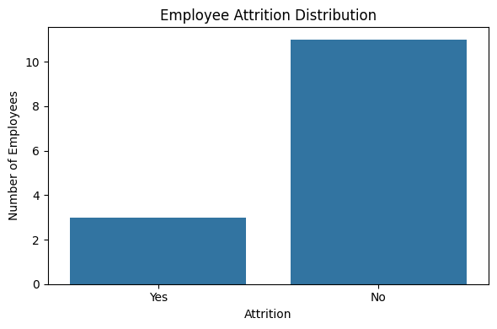
Figure 4.2: Attrition by Department or Job Role
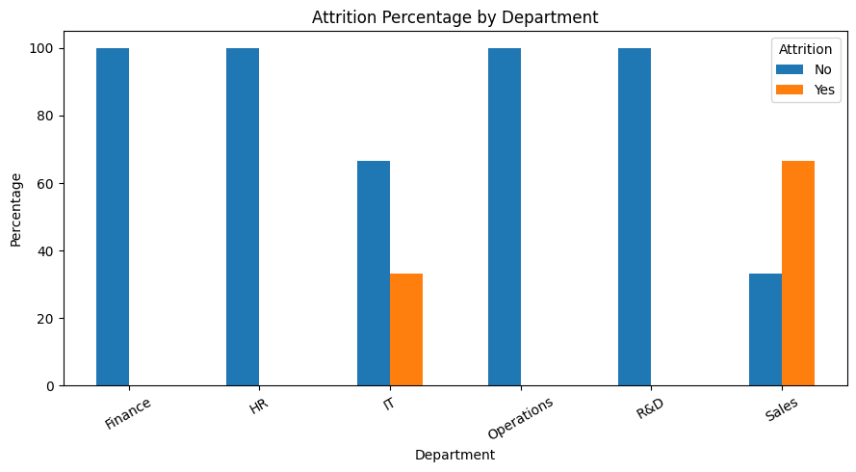

Figure 4.3: Numeric Feature Correlation Heatmap
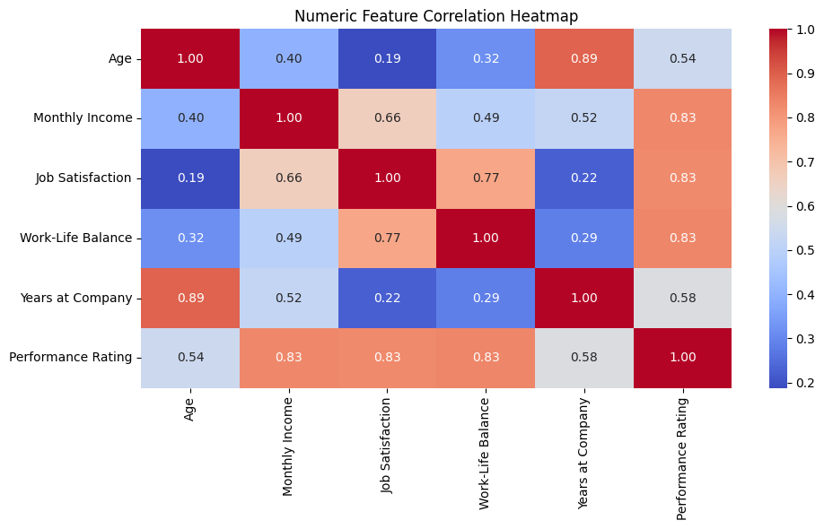

CHAPTER 5 – MODEL DEVELOPMENT
- 5.1 Logistic Regression
Logistic Regression is a baseline classification algorithm that estimates the probability of an employee belonging to a class based on a weighted combination of input features. Scaling numeric features and encoding categorical variables are typically appropriate.
- 5.2 Decision Tree Classifier
A Decision Tree learns a sequence of feature-based rules. It is relatively easy to interpret, but a deep tree may overfit the training data. Parameters such as maximum depth can help control complexity.
- 5.3 Random Forest Classifier
Random Forest combines predictions from multiple decision trees. It can represent nonlinear patterns and interactions and can provide feature-importance estimates. Its importance scores should be interpreted as model-specific signals, not causal evidence.
- 5.4 Training Procedure
Train all candidate models using the same training/test split and consistent preprocessing. If classes are imbalanced, consider class-sensitive metrics and suitable class-weight options. Tune hyperparameters only using training data or cross-validation, not by repeatedly optimizing against the test set.
- 5.5 Models Included
- Logistic Regression
- Decision Tree Classifier
- Random Forest Classifier
Additional models such as Support Vector Machine or K-Nearest Neighbors may be explored if time and dataset size permit.

CHAPTER 6 – MODEL EVALUATION
- 6.1 Accuracy
Accuracy is the proportion of test records classified correctly. It can be misleading when one class is much more common than the other.
- 6.2 Precision
Precision measures, among records predicted as a particular class, the proportion that truly belong to that class.
- 6.3 Recall
Recall measures, among actual records of a class, the proportion identified by the model.
- 6.4 F1-Score
The F1-score combines precision and recall using their harmonic mean. For imbalanced classes, report class-specific scores and/or macro and weighted averages as appropriate.
- 6.5 Confusion Matrix
The confusion matrix shows the counts of correct and incorrect predictions for each class. Label the axes clearly and state which class is treated as the positive class.
- 6.6 ROC-AUC
For binary classification, ROC-AUC may be reported when predicted probabilities or decision scores are available and the test data contain the required classes. Include the positive-class definition and avoid over-interpreting a score from a small test set.
6.7 Actual Results Table
Model | Accuracy | Precision | Recall | F1-score | ROC-AUC
Logistic Regression | [insert] | [insert] | [insert] | [insert] | [insert]
Decision Tree | [insert] | [insert] | [insert] | [insert] | [insert]
Random Forest | [insert] | [insert] | [insert] | [insert] | [insert]
Logistic Regression | [run notebook] | [run notebook] | [run notebook] | [run notebook] | [run notebook]
Decision Tree | [run notebook] | [run notebook] | [run notebook] | [run notebook] | [run notebook]
Random Forest | [run notebook] | [run notebook] | [run notebook] | [run notebook] | [run notebook]
Note: Do not enter guessed scores. Fill this table with the actual notebook output.

CHAPTER 7 – MODEL COMPARISON
Compare all models using the same test records and consistent metrics. For an imbalanced attrition label, consider macro F1-score, class-specific precision and recall, and the confusion matrix rather than choosing a model by accuracy alone.
Select the best-performing model based on the project’s stated evaluation priorities and observed test results. Explain trade-offs—for example, a model may identify more attrition cases but also generate more false positives. A model’s test performance on one dataset does not guarantee performance in another organization.
Best model: [insert after running the notebook]
Reason for selection: [describe the measured metrics and relevant trade-offs]
Comparison chart: [insert generated model-comparison visualization]

CHAPTER 8 – RESULT ANALYSIS
- 8.1 Attrition Patterns
Summarize the patterns actually observed in the charts. Mention which groups had higher or lower observed attrition rates only when supported by the computed results, and include group sizes.
- 8.2 Feature Importance
For tree-based models, report the feature-importance values or a suitable explanation method generated by the notebook. Importance indicates how the fitted model used the available features; it does not prove that a feature caused an employee to leave.
- 8.3 Model Performance
Discuss the evaluation results, class imbalance, errors visible in the confusion matrix, and any differences between precision and recall. Avoid claiming that the model is reliable without adequate validation.
- 8.4 Limitations
- Results depend on dataset quality, size, source, and representativeness.
- Missing, biased, or inconsistently defined attributes may affect results.
- Attrition patterns do not establish causal relationships.
- A single train-test split may produce unstable metrics.
- Employee data are sensitive and must be handled with appropriate privacy safeguards.
- A model should not be used as the sole basis for decisions about hiring, promotion, performance, or continued employment.
- 8.5 Future Improvements
- Use a larger, representative, well-documented dataset.
- Apply stratified cross-validation and careful hyperparameter tuning.
- Evaluate calibration and class-specific error rates.
- Review model fairness across relevant groups, where lawful and appropriate.
- Protect privacy and restrict access to employee-level data.
- Validate any proposed use with domain experts and appropriate governance.
- 8.6 Real-World Applications
Aggregated attrition analysis may help HR teams review workforce trends, investigate employee feedback, and evaluate retention initiatives. Any model-assisted use should be transparent, carefully validated, privacy-preserving, and subject to human review.

PROGRAM

# EMPLOYEE ATTRITION ANALYSIS AND PREDICTION

# 1. Import Libraries
import pandas as pd
import numpy as np
import matplotlib.pyplot as plt
import seaborn as sns

from google.colab import files
from sklearn.model_selection import train_test_split
from sklearn.compose import ColumnTransformer
from sklearn.pipeline import Pipeline
from sklearn.preprocessing import OneHotEncoder, StandardScaler, LabelEncoder
from sklearn.impute import SimpleImputer
from sklearn.linear_model import LogisticRegression
from sklearn.tree import DecisionTreeClassifier
from sklearn.ensemble import RandomForestClassifier
from sklearn.metrics import (
accuracy_score, precision_score, recall_score,
f1_score, confusion_matrix, classification_report,
roc_auc_score, ConfusionMatrixDisplay, RocCurveDisplay
)

print("Libraries imported successfully!")

# 2. Upload Dataset
print("Upload your Employee Attrition CSV or Excel file:")
uploaded = files.upload()
file_path = next(iter(uploaded.keys()))

if file_path.lower().endswith((".xlsx", ".xls")):
df = pd.read_excel(file_path)
else:
df = pd.read_csv(file_path)

# 3. Inspect Dataset
df.columns = df.columns.astype(str).str.strip()

print("\nFirst 5 Records:")
display(df.head())

print("\nDataset Shape:", df.shape)
print("\nColumn Names:")
print(df.columns.tolist())

print("\nMissing Values:")
print(df.isnull().sum())

print("\nDuplicate Records:", df.duplicated().sum())

# 4. Clean Dataset
df = df.drop_duplicates().copy()

# Find Attrition column, ignoring capitalisation/spaces
target = next(
(c for c in df.columns if c.strip().lower() == "attrition"),
None
)

if target is None:
raise ValueError(
"Attrition column not found. Check your dataset column names."
)

df = df.dropna(subset=[target]).copy()
df[target] = df[target].astype(str).str.strip()
df = df[df[target] != ""].copy()

if df[target].nunique() < 2:
raise ValueError("Attrition must contain at least two classes.")

print("\nCleaned Dataset Shape:", df.shape)
print("\nAttrition Counts:")
print(df[target].value_counts())

# 5. Exploratory Data Analysis (EDA)

# Attrition distribution
plt.figure(figsize=(6, 4))
sns.countplot(data=df, x=target)
plt.title("Employee Attrition Distribution")
plt.xlabel("Attrition")
plt.ylabel("Number of Employees")
plt.tight_layout()
plt.show()

# Attrition percentages
print("\nAttrition Percentage:")
print((df[target].value_counts(normalize=True) * 100).round(2))

# Department-wise attrition, if available
dept_col = next(
(c for c in df.columns if c.lower() == "department"),
None
)

if dept_col:
dept_data = pd.crosstab(
df[dept_col], df[target], normalize="index"
) * 100

dept_data.plot(kind="bar", figsize=(9, 5))
plt.title("Attrition Percentage by Department")
plt.ylabel("Percentage")
plt.xticks(rotation=30)
plt.tight_layout()
plt.show()

# Numeric correlation heatmap
numeric_df = df.select_dtypes(include=np.number)

if numeric_df.shape[1] >= 2:
plt.figure(figsize=(10, 6))
sns.heatmap(
numeric_df.corr(), annot=True,
cmap="coolwarm", fmt=".2f"
)
plt.title("Numeric Feature Correlation Heatmap")
plt.tight_layout()
plt.show()

# 6. Prepare Features and Target
X = df.drop(columns=[target]).copy()
y = df[target].copy()

# Remove common ID, constant, and leakage-prone columns
drop_cols = [
c for c in X.columns
if c.strip().lower() in [
"employeenumber", "employeeid", "id",
"employeecount", "over18", "standardhours"
]
]

X = X.drop(columns=drop_cols, errors="ignore")

# Remove columns containing no usable values
X = X.dropna(axis=1, how="all")

# Remove constant columns
constant_cols = [
c for c in X.columns if X[c].nunique(dropna=True) <= 1
]
X = X.drop(columns=constant_cols, errors="ignore")

if X.shape[1] == 0:
raise ValueError("No usable feature columns remain.")

# Encode target labels
label_encoder = LabelEncoder()
y_encoded = label_encoder.fit_transform(y)

print("\nTarget Classes:", list(label_encoder.classes_))
print("Features Used:", X.columns.tolist())

# 7. Train-Test Split
class_counts = pd.Series(y_encoded).value_counts()
stratify_values = y_encoded if class_counts.min() >= 2 else None

X_train, X_test, y_train, y_test = train_test_split(
X, y_encoded,
test_size=0.20,
random_state=42,
stratify=stratify_values
)

print("\nTraining Records:", len(X_train))
print("Testing Records:", len(X_test))

# 8. Preprocess Numeric and Categorical Features
numeric_features = X.select_dtypes(
include=np.number
).columns.tolist()

categorical_features = [
c for c in X.columns if c not in numeric_features
]

numeric_pipeline = Pipeline([
("imputer", SimpleImputer(strategy="median")),
("scaler", StandardScaler())
])

categorical_pipeline = Pipeline([
("imputer", SimpleImputer(strategy="most_frequent")),
("encoder", OneHotEncoder(handle_unknown="ignore"))
])

preprocessor = ColumnTransformer([
("numeric", numeric_pipeline, numeric_features),
("categorical", categorical_pipeline, categorical_features)
])

# 9. Create Three ML Models
models = {
"Logistic Regression": LogisticRegression(
max_iter=2000, class_weight="balanced"
),
"Decision Tree": DecisionTreeClassifier(
max_depth=6, random_state=42,
class_weight="balanced"
),
"Random Forest": RandomForestClassifier(
n_estimators=100, max_depth=10,
random_state=42, class_weight="balanced"
)
}

results = []
trained_models = {}

# 10. Train and Evaluate Models
for name, classifier in models.items():
print("\n" + "=" * 50)
print(name)

model = Pipeline([
("preprocessor", preprocessor),
("classifier", classifier)
])

model.fit(X_train, y_train)
predictions = model.predict(X_test)
trained_models[name] = model

accuracy = accuracy_score(y_test, predictions)
precision = precision_score(
y_test, predictions, average="weighted",
zero_division=0
)
recall = recall_score(
y_test, predictions, average="weighted",
zero_division=0
)
f1 = f1_score(
y_test, predictions, average="weighted",
zero_division=0
)

auc = np.nan
if len(label_encoder.classes_) == 2:
try:
probabilities = model.predict_proba(X_test)[:, 1]
if len(np.unique(y_test)) == 2:
auc = roc_auc_score(y_test, probabilities)
except (ValueError, IndexError):
pass

results.append({
"Model": name,
"Accuracy": accuracy,
"Precision": precision,
"Recall": recall,
"F1 Score": f1,
"ROC-AUC": auc
})

print("Accuracy:", round(accuracy, 4))
print("Precision:", round(precision, 4))
print("Recall:", round(recall, 4))
print("F1 Score:", round(f1, 4))
print("ROC-AUC:", round(auc, 4) if not np.isnan(auc) else "N/A")

print("\nClassification Report:")
print(classification_report(
y_test, predictions,
labels=np.arange(len(label_encoder.classes_)),
target_names=[str(c) for c in label_encoder.classes_],
zero_division=0
))

ConfusionMatrixDisplay.from_predictions(
y_test, predictions,
labels=np.arange(len(label_encoder.classes_)),
display_labels=label_encoder.classes_,
cmap="Blues",
xticks_rotation=30
)
plt.title(f"Confusion Matrix - {name}")
plt.tight_layout()
plt.show()

# 11. Compare Models
comparison = pd.DataFrame(results).sort_values(
by="F1 Score", ascending=False
)

print("\nMODEL COMPARISON")
display(comparison.round(4))

best_name = comparison.iloc[0]["Model"]
print("Best Model by Weighted F1 Score:", best_name)

comparison.set_index("Model")[
["Accuracy", "Precision", "Recall", "F1 Score"]
].plot(kind="bar", figsize=(10, 5))

plt.title("Employee Attrition Model Comparison")
plt.ylabel("Score")
plt.ylim(0, 1.05)
plt.xticks(rotation=20)
plt.tight_layout()
plt.show()

# 12. ROC Curve (Binary Classification)
if len(label_encoder.classes_) == 2 and len(np.unique(y_test)) == 2:
plt.figure(figsize=(7, 5))
for name, model in trained_models.items():
RocCurveDisplay.from_estimator(
model, X_test, y_test, name=name
)
plt.title("ROC Curves - Model Comparison")
plt.tight_layout()
plt.show()

# 13. Feature Importance (Tree Models)
for name in ["Decision Tree", "Random Forest"]:
model = trained_models[name]
fitted_preprocessor = model.named_steps["preprocessor"]
classifier = model.named_steps["classifier"]

feature_names = fitted_preprocessor.get_feature_names_out()
importances = classifier.feature_importances_

importance_df = pd.DataFrame({
"Feature": feature_names,
"Importance": importances
}).sort_values("Importance", ascending=False).head(15)

print(f"\nTop Features - {name}")
display(importance_df)

plt.figure(figsize=(9, 5))
sns.barplot(
data=importance_df,
x="Importance", y="Feature"
)
plt.title(f"Feature Importance - {name}")
plt.tight_layout()
plt.show()

# 14. Save Results
comparison.to_csv("employee_attrition_model_comparison.csv", index=False)
files.download("employee_attrition_model_comparison.csv")

print("\nPROJECT COMPLETED SUCCESSFULLY!")
print("Use the actual output and graphs in your project report.")

CONCLUSION
This project defines an end-to-end workflow for Employee Attrition Analysis and Prediction using data preparation, exploratory data analysis, visualization, and three supervised classification models: Logistic Regression, Decision Tree, and Random Forest. The models are evaluated with suitable classification metrics and compared to identify the most appropriate result for the selected dataset.
The final conclusions, charts, dataset statistics, and model scores must be inserted after running the analysis on the actual employee dataset. Observed associations should not be interpreted as causes, and model outputs should not be used alone to make decisions about individual employees.

REFERENCES
- Scikit-learn documentation: https://scikit-learn.org/stable/
- Pandas documentation: https://pandas.pydata.org/docs/
- Matplotlib documentation: https://matplotlib.org/stable/
- Seaborn documentation: https://seaborn.pydata.org/
- Dataset source and documentation: [cleaned dataset]

APPENDIX – DELIVERABLES CHECKLIST
- □ Employee dataset used and its source documented
- □ Cleaned dataset saved, with changes documented
- □ Jupyter Notebook / Google Colab Notebook
- □ EDA charts and summary tables
- □ Trained model outputs and evaluation metrics
- □ Confusion matrices and model comparison chart
- □ Final PDF report
- □ PPT presentation (10–12 slides)

